EENG 3920: Modern Communication Systems Design

# Lab 1: Active Filter Networks

Group 5

Victor Rodriguez (victorcuba92@gmail.com)

Mohammad Qawash (MohammadQawash@my.unt.edu)

John Rolfe (JohnRolfe@my.unt.edu)

Natalie Powers (NataliePowers@my.unt.edu)

Nathan Ruprecht (nathan.ruprecht@outlook.com)

**Date of Submission: 4 February 2016**

**Section 1**

**Introduction and Learning Objective**

EENG 3920 is the project design course for electronics courses. Students are required to design electronic communication systems with electronic devices such as MOS transistors, capacitors and resistors. The design and simulation tool is NI ELVIS platform. Topics include LC circuits and oscillators, AM modulation, SSB communications, and FM modulation. At the end of the class, the student should be able to: Understand fundamental concepts and circuits used in communication systems; Describe principles and theory of various communication techniques such as AM, FM, and SSB; Conduct effective analysis and interpretation of the experiments; Demonstrate the ability to identify, analyze, and solve technical problems; Creatively apply the course topics to designs; Simulate and analyze advance electronics circuits with NI ELVIS instruments and other test equipment.

**Safety guidelines**

As mentioned in the lab procedures, safety is extremely important in the lab. In the event of electrical fire, the session 1 lecture note states to use the fire extinguisher, located at the front of the lab, then to vacate the lab, close the door and ring the fire alarm.

**Section 2 / 3**

**Theoretical Background**

A breadboard is used to build and test circuits quickly before finalizing any circuit design. The breadboard has many holes into which circuit components like ICs and resistors can be inserted. The bread board has strips of metal which run underneath the board and connect the holes on the top of the board. Note that the top and bottom rows of holes are connected horizontally while the remaining holes are connected vertically. To use the bread board, the legs of components are placed in the holes. Each set of holes connected by a metal strip underneath forms a node. A node is a point in a circuit where two components are connected. Connections between different components are formed by putting their legs in a common node.

**Basic Instruments**

The basic instruments we used in this lab were the breadboard, oscilloscope, and waveform generator.

**Exercises**

In this experiment you will be assigned a number of the following active filter circuits to build and test. You should follow each of the steps of the test procedure for the circuit assigned.

Part I – Low-Pass Filter

Part II – High-Pass Filter

Part III – Bandpass Filter

Part IV – Notch Filter

Part I: The Butterworth Second Order Low-Pass Active Filter

We were given the schematic for a low-pass filter. We did circuit analysis to find the critical frequency and frequency response (or gain in dB). We used excel so that we applied our theoretical values to the test frequencies in Hz: 100, 200, 300, 400, 500, 600, 700, 800, 900, 1k, 2k, 3k, 4k, 5k, 6k, 7k, 8k, 9k, 10k. We then built the circuit and measured the output voltage at each frequency. The input voltage was constant at 0.5V so the gain in dB is 20*log(Vo/0.5).

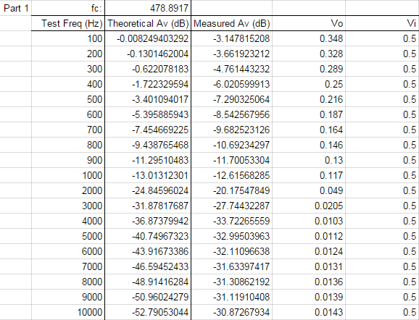

We again used excel to plot the theoretical values versus the measured. Of course, it is not an ideal filter, but the idea of lower frequencies being allowed to pass through the circuit is present and easy to see.

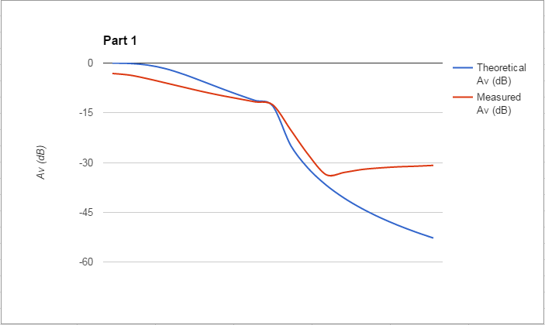

Part II: The Butterworth Second Order High-Pass Active Filter

We were given the schematic for a high-pass filter. We did circuit analysis to find the critical frequency and frequency response (or gain in dB). We used excel so that we applied our theoretical values to the test frequencies in Hz: 100, 200, 300, 400, 500, 600, 700, 800, 900, 1k, 2k, 3k, 4k, 5k, 6k, 7k, 8k, 9k, 10k. We then built the circuit and measured the output voltage at each frequency. The input voltage was constant at 0.5V so the gain in dB is 20*log(Vo/0.5).

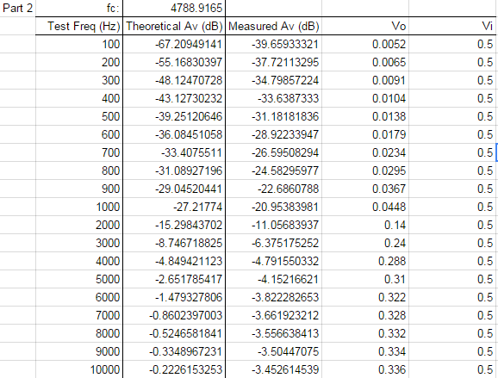

We again used excel to plot the theoretical values versus the measured. Of course, it is not an ideal filter, but the idea of higher frequencies being allowed to pass through the circuit is present and easy to see.

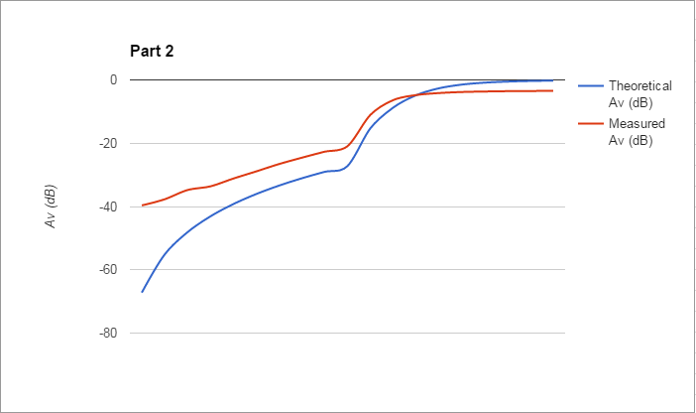

Part III: The Active Bandpass Filter

We were given the schematic for a bandpass filter. We did circuit analysis to find the center frequency, gain (in dB), the bandwidth, the high frequency cutoff, and low frequency cutoff. We then built the circuit and measured the output voltage at each frequency to calculate the gain in decibels. Seeing the gain in decibels gave us a picture of how the filter responded to frequency change.

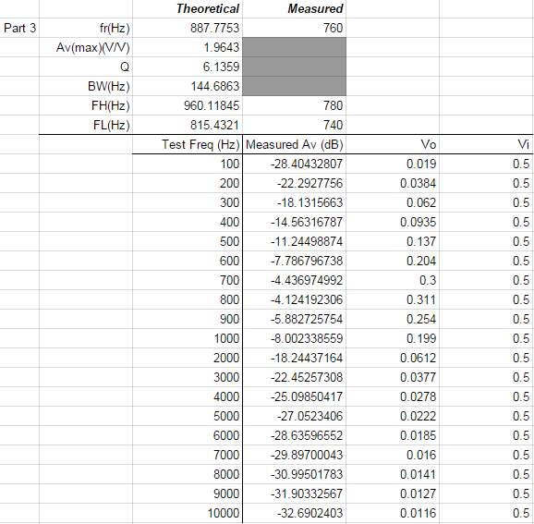

We again used excel to plot the measured values. Of course, it is not an ideal filter, but the idea of a band of frequencies being allowed to pass through the circuit is present and easy to see.

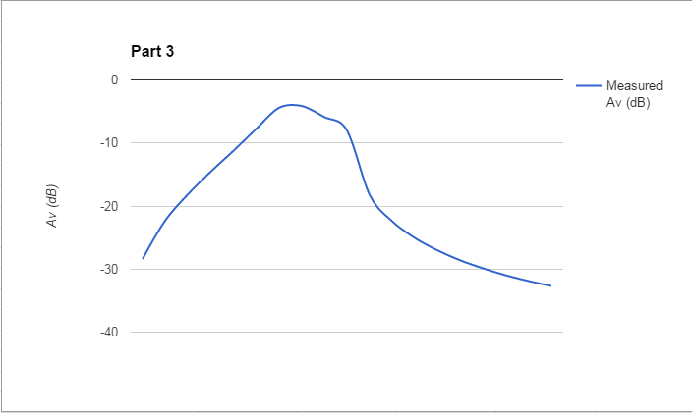

Part IV: The Active Notch Filter

We were given the schematic for a bandreject filter. We did circuit analysis to find the center frequency, gain (in dB), the bandwidth, the high frequency cutoff, and low frequency cutoff. We then built the circuit and measured the output voltage at each frequency to calculate the gain in decibels. Seeing the gain in decibels gave us a picture of how the filter responded to frequency change.

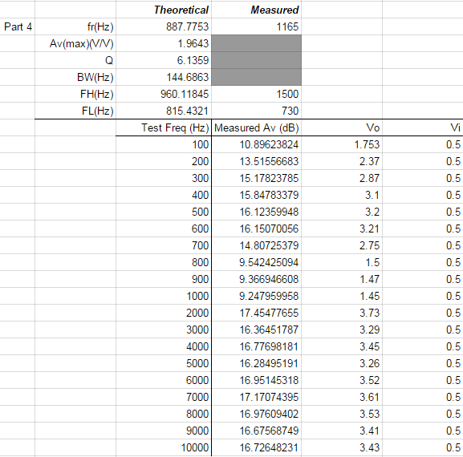

We again used excel to plot the measured values. Of course, it is not an ideal filter, but the idea of a band of frequencies being allowed to pass through the circuit is present and easy to see. It threw us off that the gain was so high for each value, yet the differences painted a picture of lower frequencies passing through, a band of frequencies being rejected, and then higher frequencies again passing though.

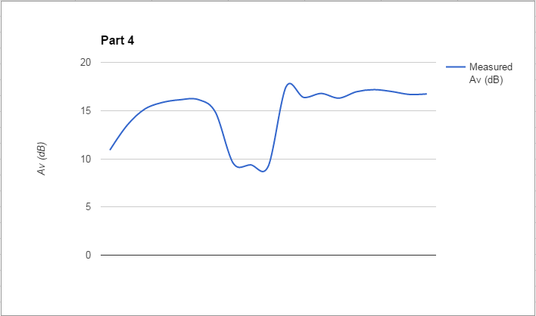

**Section 4**

**Conclusion**

In this lab we learned how to build and apply the 4 types of filters (low pass, high pass, band pass, and band reject). We troubleshot a lot of our circuit. No measured values matched the theoretical values on the first try, which emphasized even more the importance of taking time to calculate theoretical values. Our group had to have patience and work well together, especially since we didn’t know each other before. We became very familiar with knowing what the gain in decibels translate to as far as making a picture for how the circuit is acting.

# References

Agilent Technologies, 2007, *Agilent 34401A 6 ½ Digit Multimeter, User’s Guide*.